

Philip BAMBADE
Phone : 01 64 46
Fax : 01
Mail : bambade@lal.in2p3.fr

Visite de Monsieur Satoshi Odoï

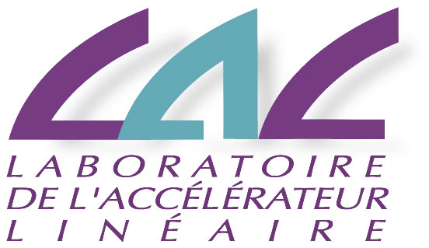

et de Monsieur Ichiro Ikeda
15 mai 2014

9:00 – 10:45
Laboratoire de l’Accélérateur Linéaire :
- Introduction to the French contribution to XFEL
- Visit to the XFEL coupler conditioning facility

11:11 – 12:30
Saclay :
- French contribution to XFEL and extrapolation to ILC
- Visit of “XFEL village” of assembly & tests of XFEL cryomodules

12:45 – 14:00
- Lunch at Saclay

14:00 – 15:30
Ecole Polytechnique
- Apollon 10PW laser project



